Final Project Proposal : Currency & Crypto Explorer
Jose Sanchez

Overview
This project takes the challenge of acces to reliable info about crypto and currency exchange, this App takes information, offering real-time conversion and insights.

Target audience
The target audience includes international travelers, economics students, and cryptocurrency enthusiasts
Major Functions
Currency converter – Convert between major world currencies.
- Real-time exchange rates – Display updated rates from the API.
- Cryptocurrency prices – Show current values for popular cryptos.
- Historical charts – Graphs of past exchange rates and crypto trends.
- Favorites list – Save preferred currencies and cryptos in localStorage.
- Comparison tool – Compare two currencies or cryptos side by side.
- Price alerts – Notify users when a currency or crypto crosses a threshold.
- Responsive design – Optimized for mobile and desktop.
- Export results – Generate a simple report of conversions.
- Dark mode – Toggle between light and dark themes
Wireframes
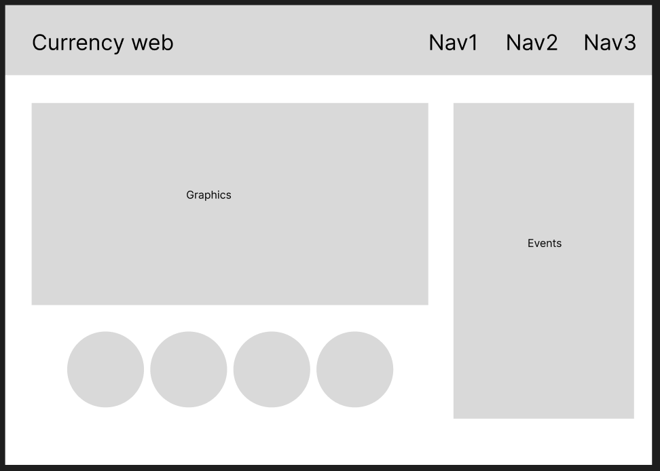
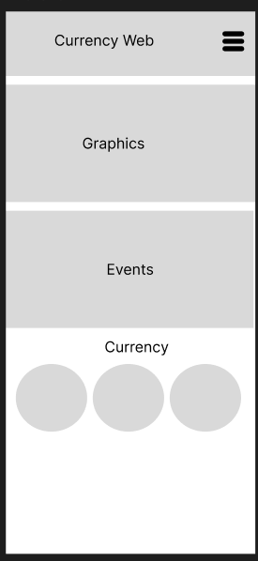
Desktop view Mobile view

External Data Sources
ExchangeRate API – Provides currency exchange data (name, code, rate, date, etc.).
CoinGecko API – Provides cryptocurrency data (name, symbol, price, market cap, volume, etc.).
Module List
index.html – Homepage structure.
styles.css – Styling and responsive design.
main.js – Entry point and app initialization.
currency.js – Handles currency API calls and conversions.
crypto.js – Handles crypto API calls and charts.
utils.js – Helper functions (localStorage, formatting).
Graphic identity
Color scheme:
Gold (#f9c74f), black (#222), gray (#adb5bd)
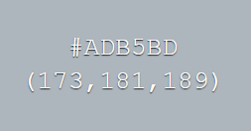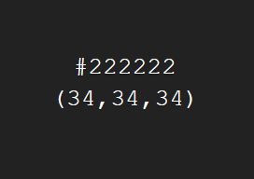

Typography
tittle: Roboto
Body: roboto
Schedule (Weeks 5–7)
- Week 5: Integrate ExchangeRate API and CoinGecko API, display basic conversions.
- Week 6: Add historical charts, favorites, and comparison features.
- Week 7: Implement alerts, finalize design, test responsiveness, and deploy

Trello Board
A Trello board will be created with columns: Backlog, Week 5, Week 6, Week 7, Done. Each card will represent deliverables such as API integration, UI design, chart rendering, and deployment.
Challenges
Handling real-time data updates and API rate limits.
Managing differences in data formats between currency and crypto APIs.
Optimizing chart rendering for performance.
Ensuring usability across devices with responsive design.

